Test and Analysis for Single Point Localization in One-Dimension

* **Test Situation**

According to TDOA algorithm, indoor environment is applied to simulate one-dimension scenario. Base stations No. 3 and No. 4 are hang on opposite walls and the data is collected for the points between them by PC.

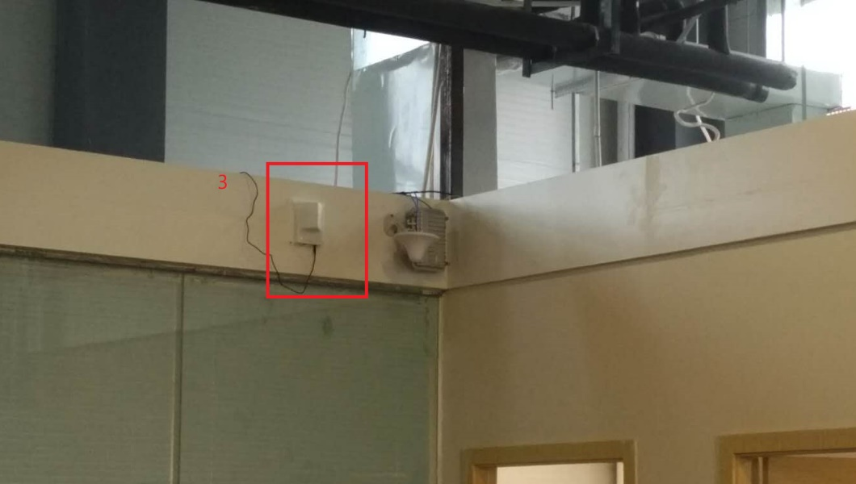

Fig 1 No.3 base station

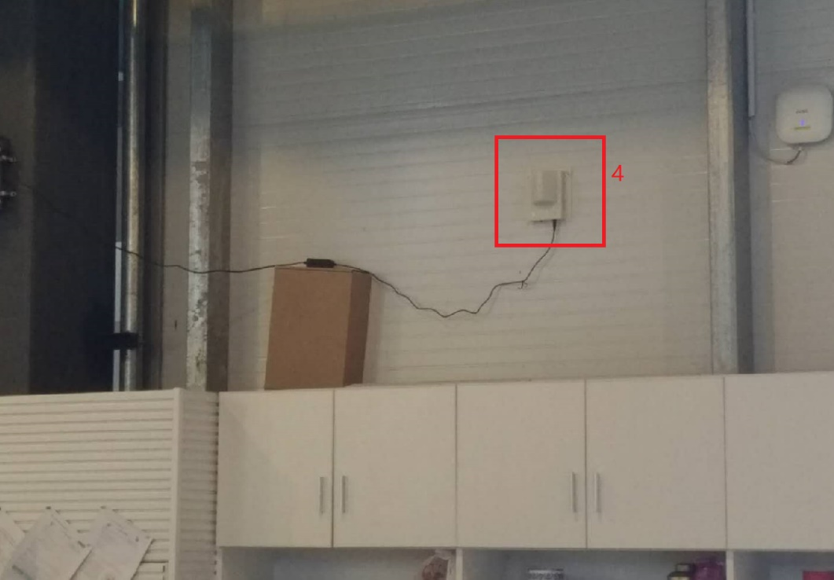

Fig 2 No.4 base station

* **Test Result**

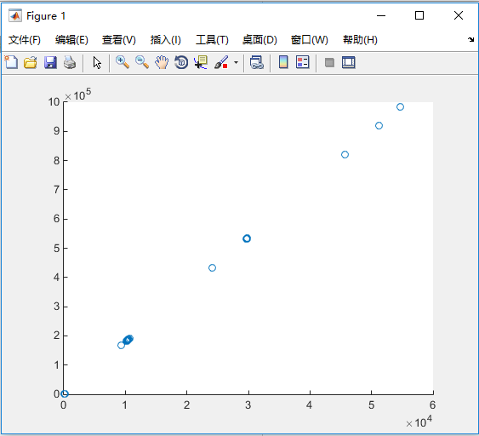

Fig 3 graph drawn from all collected data

The calculated location graph above drawn according to the collected data whose number is 7412.

Since the dirty data exists, error lies in some of the points.

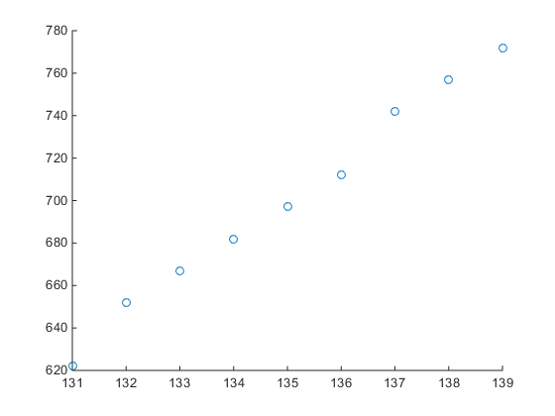

Fig 4 graph drawn from filtered data

After removing dirty data, the remaining 6152 groups of data can derive above location separation.

The following table is the summary for filtered data.

|  |  |  |  |
| --- | --- | --- | --- |
| Order | Parameter | X coordinate (mm) | Y coordinate (mm) |
| 1 | Minima | 131 | 622 |
| 2 | Maxima | 139 | 772 |
| 3 | Average | 134.2 | 685 |
| 4 | Median | 134 | 682 |
| 5 | Mode | 134 | 682 |
| 6 | RMS | 0.6452 | 10.07 |